

NALAIYATHIRAN

TEAM NAME: MEDICINE REMINDER


TEAM ID: PNT2022TMID47535

EMPATHY MAP

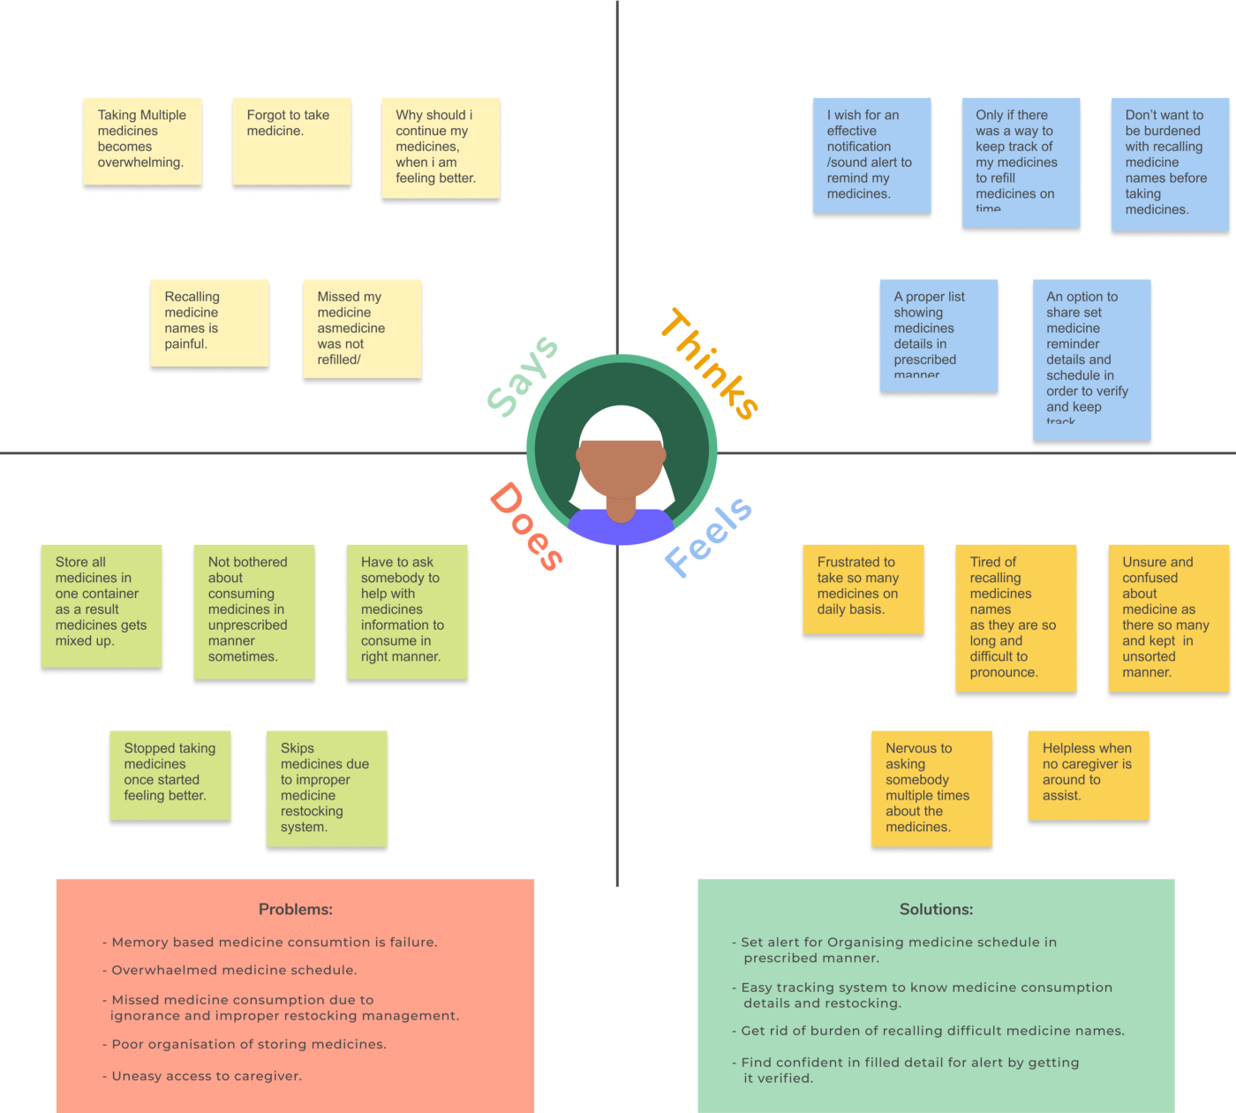

TEAM MEMBERS
K.VISHALI (910419106013)
S.ISWARYA (910419106002)
M.SNEGA (910419106008)
R.PANDISELVI (910419106007)

